**SOCCER BOT**

A soccer bot using a Bluetooth module is a robotic device designed to play soccer or engage in soccer-related activities

**The soccer bot can be used for various purposes, such as:**

**Soccer training: The bot can simulate opponents or teammates, providing a training partner for practicing dribbling, shooting, passing, or tactical maneuvers.**

**Recreational play: The bot can be used for fun and entertainment, allowing you to play soccer-like games with friends or family members.**

**Educational purposes: Building and programming a soccer bot can be a great way to learn about robotics, electronics, programming, and problem-solving.**

**Research and development: Soccer bots can be used in research projects to explore advanced algorithms, artificial intelligence, or autonomous behavior.**

**The specific use and functionalities of the soccer bot can be customized based on your requirements and programming capabilities.**

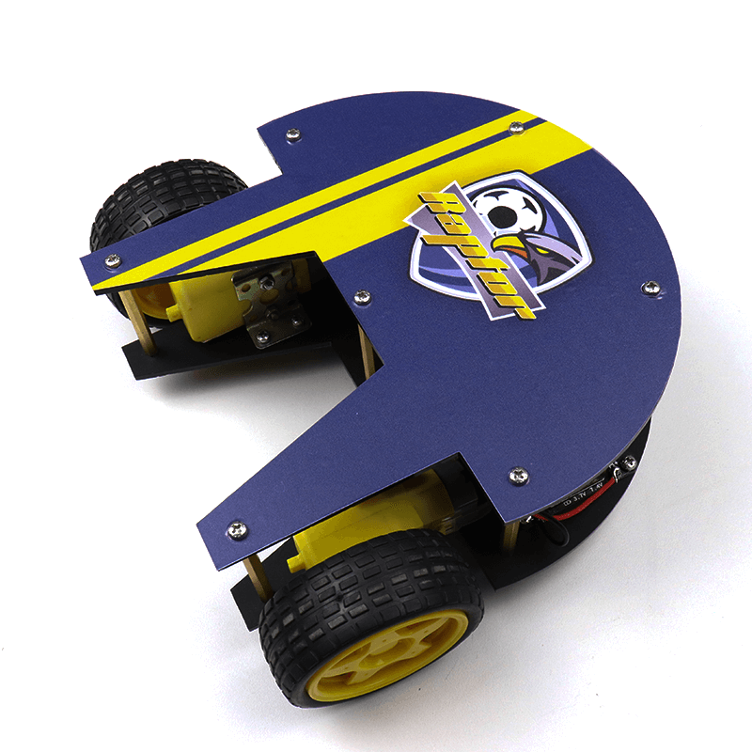

1. **Hardware Components:**

**Soccer bot chassis: This will be the physical body of the bot, which you can build or purchase.**

**Motors and wheels: Install motors and wheels on the chassis to enable movement.**

**Arduino or microcontroller: Choose a microcontroller like Arduino to control the bot's motors and Bluetooth module.**

**Bluetooth module: Select a Bluetooth module (e.g., HC-05 or HC-06) that supports the required communication between the bot and the controlling device.**

**Power supply: Provide power to the motors and microcontroller using batteries or a suitable power source.**

1. **Assembly:**

**Mount the motors and wheels onto the chassis.**

**Connect the motors to the Arduino or microcontroller, ensuring proper wiring.**

**Connect the Bluetooth module to the Arduino, following the module's datasheet or tutorial.**

1. **Programming:**

**Write the necessary code to control the motors using the Arduino IDE or a suitable programming environment.**

**Implement Bluetooth communication protocols to receive commands from the controlling device and interpret them to control the motors.**

1. **Controlling Device:**

**Install a Bluetooth terminal app on your mobile device or computer (e.g., Serial Bluetooth Terminal for Android).**

**Pair your controlling device with the soccer bot's Bluetooth module.**

**Open the Bluetooth terminal app and establish a connection with the bot.**

**Code : -**

#include <AFMotor.h>

#include <SoftwareSerial.h>

SoftwareSerial BTSerial(0, 1);

//initial motors pin

AF_DCMotor motor1(1, MOTOR12_1KHZ);

AF_DCMotor motor2(2, MOTOR12_1KHZ);

AF_DCMotor motor3(3, MOTOR34_1KHZ);

AF_DCMotor motor4(4, MOTOR34_1KHZ);

char command;

void setup()

{

  Serial.begin(9600);

 // read the incoming command

  BTSerial.begin(9600); //Set the baud rate to your Bluetooth module.

}

void loop(){

   if (BTSerial.available()) { // check if data is available on Bluetooth serial

    command = BTSerial.read(); // read the incoming command

    Stop(); //initialize with motors stoped

    //Change pin mode only if new command is different from previous.

    //Serial.println(command);

    switch(command){

    case 'F':

      forward();

      break;

    case 'B':

       back();

      break;

    case 'L':

      left();

      break;

    case 'R':

      right();

      break;

    }

  }

}

void forward()

{

  motor1.setSpeed(255); //Define maximum velocity

  motor1.run(FORWARD); //rotate the motor clockwise

  motor2.setSpeed(255); //Define maximum velocity

  motor2.run(FORWARD); //rotate the motor clockwise

  motor3.setSpeed(255);//Define maximum velocity

  motor3.run(FORWARD); //rotate the motor clockwise

  motor4.setSpeed(255);//Define maximum velocity

  motor4.run(FORWARD); //rotate the motor clockwise

}

void back()

{

  motor1.setSpeed(255); //Define maximum velocity

  motor1.run(BACKWARD); //rotate the motor anti-clockwise

  motor2.setSpeed(255); //Define maximum velocity

  motor2.run(BACKWARD); //rotate the motor anti-clockwise

  motor3.setSpeed(255); //Define maximum velocity

  motor3.run(BACKWARD); //rotate the motor anti-clockwise

  motor4.setSpeed(255); //Define maximum velocity

  motor4.run(BACKWARD); //rotate the motor anti-clockwise

}

void left()

{

  motor1.setSpeed(255); //Define maximum velocity

  motor1.run(BACKWARD); //rotate the motor anti-clockwise

  motor2.setSpeed(255); //Define maximum velocity

  motor2.run(BACKWARD); //rotate the motor anti-clockwise

  motor3.setSpeed(255); //Define maximum velocity

  motor3.run(FORWARD);  //rotate the motor clockwise

  motor4.setSpeed(255); //Define maximum velocity

  motor4.run(FORWARD);  //rotate the motor clockwise

}

void right()

{

  motor1.setSpeed(255); //Define maximum velocity

  motor1.run(FORWARD); //rotate the motor clockwise

  motor2.setSpeed(255); //Define maximum velocity

  motor2.run(FORWARD); //rotate the motor clockwise

  motor3.setSpeed(255); //Define maximum velocity

  motor3.run(BACKWARD); //rotate the motor anti-clockwise

  motor4.setSpeed(255); //Define maximum velocity

  motor4.run(BACKWARD); //rotate the motor anti-clockwise

}

void Stop()

{

  motor1.setSpeed(0); //Define minimum velocity

  motor1.run(RELEASE); //stop the motor when release the button

  motor2.setSpeed(0); //Define minimum velocity

  motor2.run(RELEASE); //rotate the motor clockwise

  motor3.setSpeed(0); //Define minimum velocity

  motor3.run(RELEASE); //stop the motor when release the button

  motor4.setSpeed(0); //Define minimum velocity

  motor4.run(RELEASE); //stop the motor when release the button

}